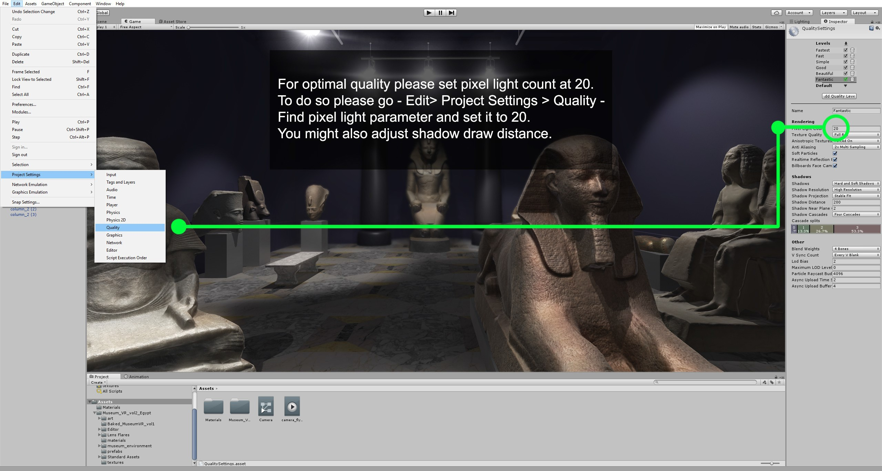
Museum VR Vol. 3

Ancient Asia Asset Pack

This pack contains a virtual museum environment filled with 23 optimized models of ancient Asian works of art. Actual ancient relics that are found on display at museums around the world were photo- scanned and optimized to be used in a variety of your Unity projects. This is the third pack from the series.

Museum VR Vol.1 Ancient Greece and Rome
Museum VR Vol.2 Ancient Egypt

The pack contains a museum scene, set up for precomputed real-time GI. VR option is enabled. FPS mode is enabled. Flying camera mode included. All assets are assigned with a standard shader material, using 2 – 4096x4096 texture maps – diffuse and normal.

Demo scene requires importing following 2 assets into your project -

Standard Assets Lens Flares

Important : After importing this asset into your project, make sure to adjust your project quality settings according to this instruction -

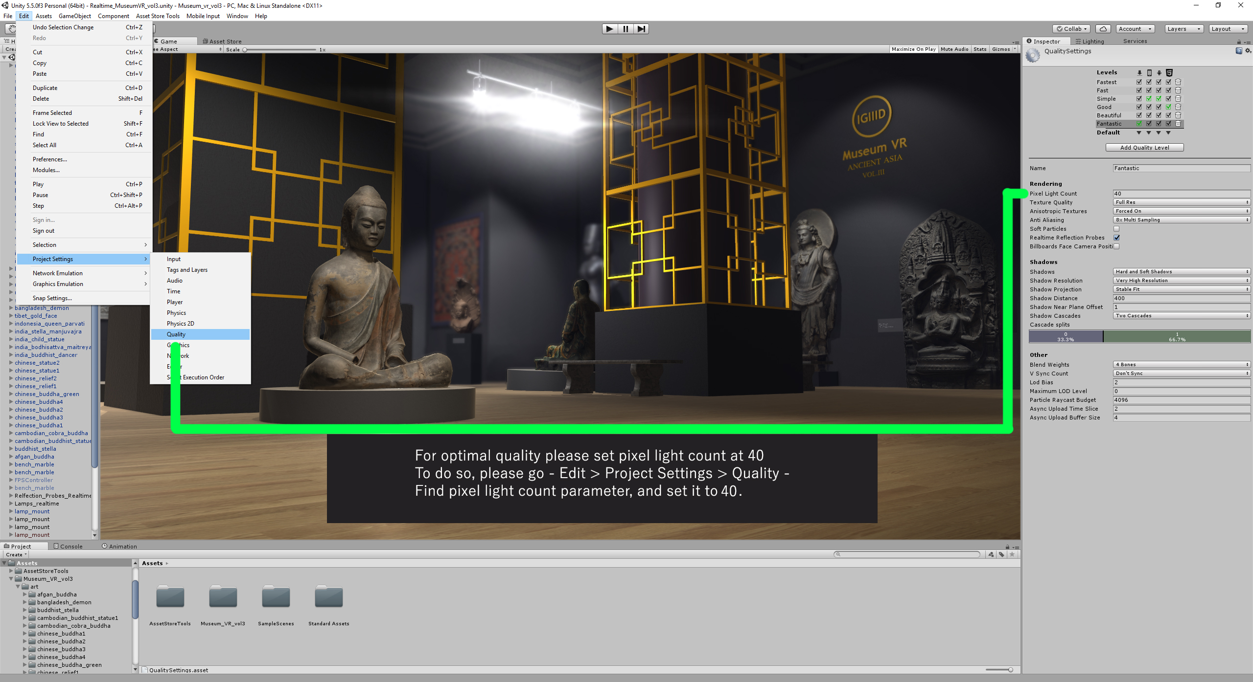

Main Features of the pack

- 1 museum room environment with columns, lights and marble benches
- 23 real world works of art from China, Cambodia, India, Tibet,Nepal, Bangladesh, Indonesia and Afghanistan.
- Descriptions to all statues and sculpture pieces.
- Average triangle count per asset is 5000

Unity's Free Lens Flare pack is used in this asset.

One or more textures on this 3D model have been created with images from CGTextures.com.
These images may not be redistributed by default, please visit www.cgtextures.com for more information."

Disclaimer: Textures taken from CGTextures.com were heavily customized to be used with 3D models in this pack, and are subject for commercial or private use. The text above simply serves as a credit and means that you can't redistribute the textures alone, however you can do so as a part of your own project or asset.

For questions and support please contact at: gulyaev.art@gmail.com

